**Work view reflection.**

I feel that working is something important in society because you need a work to survive and have incomes. Work means that you perform tasks or services in exchange of money. For the individual it may mean that we are obliged to work in order to have a good life and get money but it also can be a way of creatin social relationships and can be something you like at the end of the day.

**Life view Reflection:**

Life is a piece of eternity that we go through in order to learn and be prepared for what’s next. There are people that don’t believe this and have a darker and sadder view of life. It can be hopeless to be here, but as we learn and look for answers to our questions, we can find joy and happiness.

**Work view and Life view:**

Work and life can complement each other. If we plan good enough, we can make time for everything and that will help us to have fun, learn and be prepared for what is coming. All of it depends in our desire to succeed and in our ability to be organized. We can feel that sometimes we don’t relate both but we need to find the balance

**Keep a good time journal:**

* Wake up at 4am
* Go to work and arrive there at 4:30
* Get out of work at 7:30
* Mondays, Wednesday and Fridays go to the gym for at least 45 min
* Tuesdays and Thursdays be ready for class at 9:00
* MWF be ready for class at 11:30
* Attend class, do homework and social life until I finish classes
* Come back home MWF at 3:00pm-ish
* Come back home T, Th around 2:00pm
* Rest a little and do more homework, cook, play the guitar or learn stuff in the internet

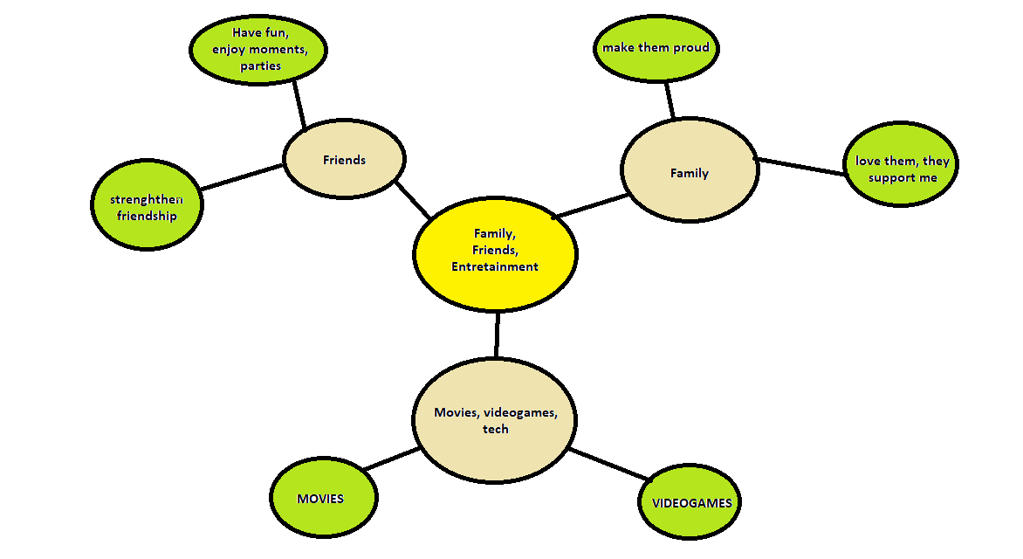**Mind Maps**

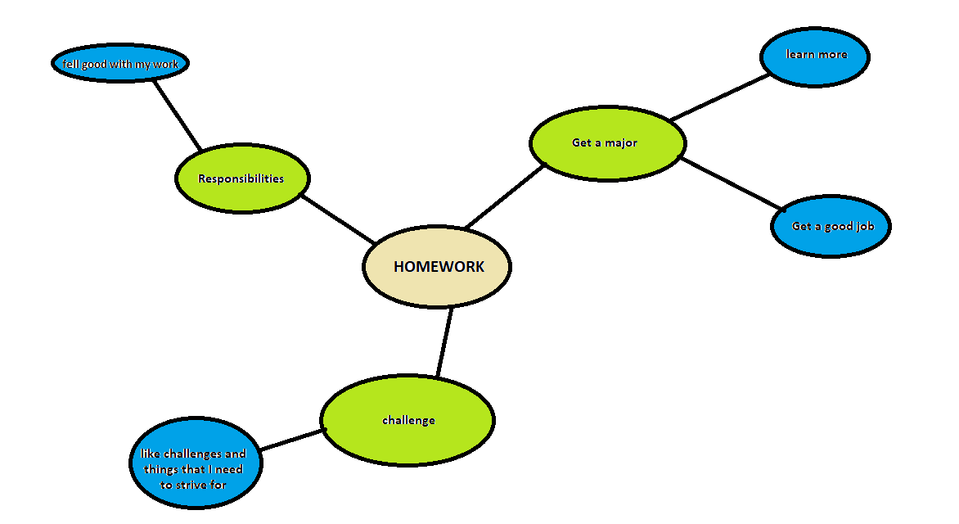

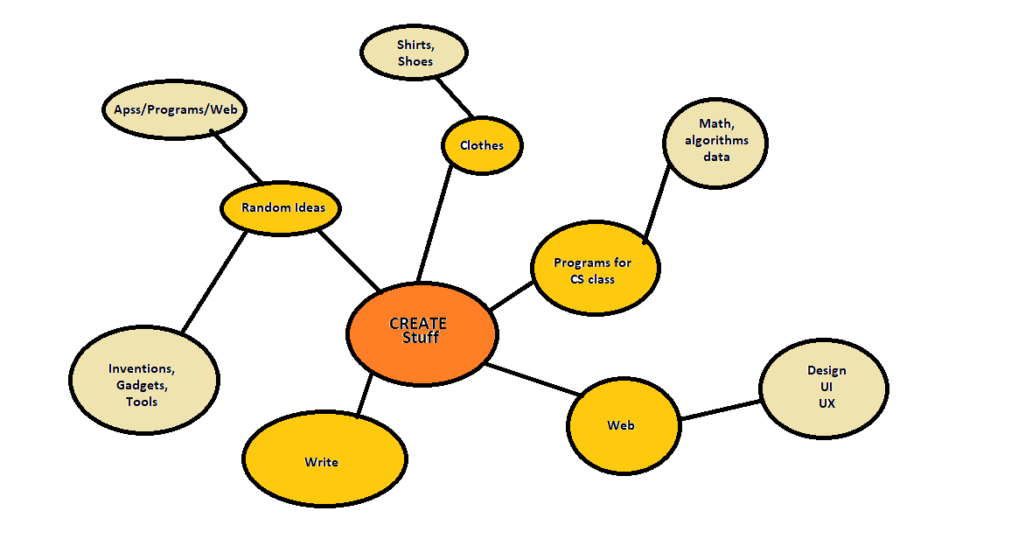

**Odyssey Plan**

**Odyssey Plan 1**: I want to be a CS graduated and would like to work with AI or Mach learning Algorithms. I plan to finish my degree by then and have had some projects done. I also plan to marry, have a daughter and be working in a good company that would help me to grow even more. I plan to do a masters and a PhD centered on AI and would like to have research books published.

* 6-word-title: Everything fine, just don’t fail classes
* Questions addressed: What happens if it gets hard? What happens if I start to dislike AI? Would I be trapped in that job forever? What If I change opinion nearly finishing my major?

**Odyssey Plan 2**: If I wasn’t able to work with computers, software or AI design; I would probably work in the design industry. I would study a Graphic Design major or Architecture in order to create and design things. I would also like to be married and have a kid by then. I would try to have my material published or built, in places where people can appreciate it.

* 6-word-title: Creative but useful plan to survive
* Questions addressed: Would that be hard? I don’t really like physics; would I fail classes? How could I get a good job for that?

**Odyssey Plan 3**: If money and image didn’t matter, I think that I would probably still to programming. I really like the freedom I have in creating useful things. I would probably develop a career in music or art too. The only issue I have with painting is that I am colorblind but I would try to bring all my ideas to live. I would like to have a brand and to develop my ideas and art.

* 6-word-title: I just care about doing what I like
* Questions addressed: Would I be really happy If I do it? Would I get tired of the same thing? Would people like my art?